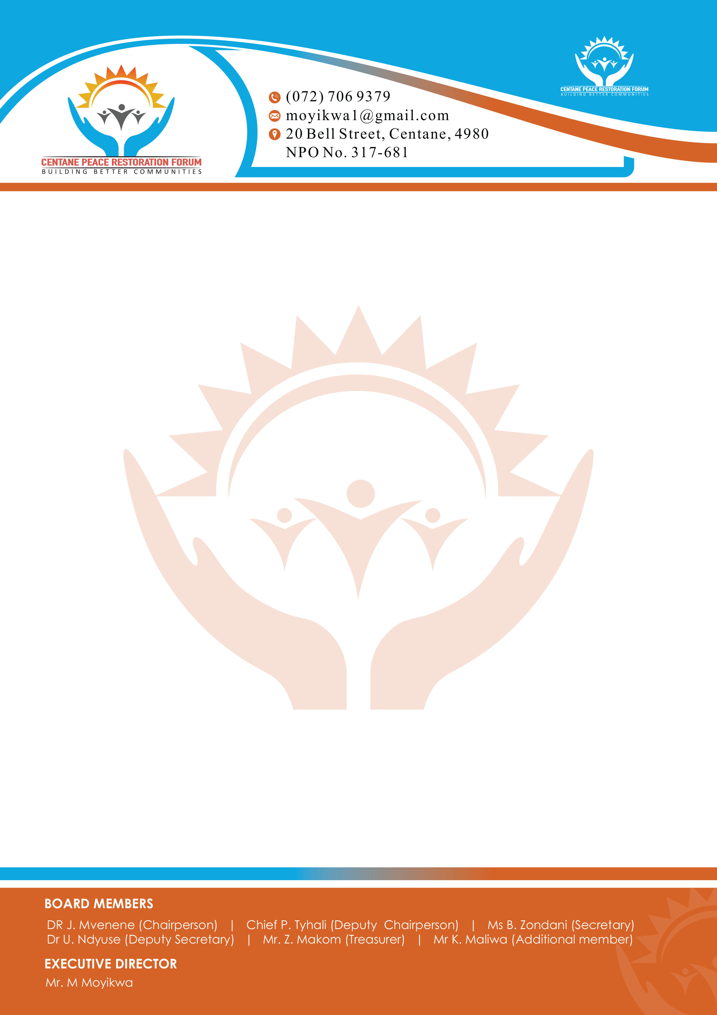

CORPORATE MEMBERSHIP APPLICATION FORM
A. ORGANIZATION INFORMATION
- Company/Organization Name: ________________________________________________
- Company Registration Number (if applicable): _________________________________
- VAT Number (if applicable): ________________________________________________
- Industry Sector: ___________________________________________________________
- Physical/ Postal Address:
B. CONTACT PERSON DETAILS
- Full Name: _______________________________________________________________
- Position/Title: ____________________________________________________________
- Telephone (Work): ____________________Mobile: _______________________________
- Email Address: ________________________
C. MEMBERSHIP TIER SELECTION
Please select your desired membership tier (tick one):
Silver Membership – R5,000 per annum
Gold Membership – R10,000 per annum
Platinum Membership – R20,000 per annum
D. PAYMENT INFORMATION
Bank: Standard Bank
Account Name: Centane Peace Restoration Forum
Account Number: 10249865937
Account Type: MyMoBiz Current Account
Branch Code: 051001 (Electronic payments)
E. AUTHORIZATION
I, the undersigned, hereby apply for corporate membership of the Centane Peace Restoration Forum and confirm the above details are correct. I understand the benefits and obligations of the selected membership tier.
Authorized Signatory Name: ____________________________________________
Signature: _________________________________
Date: ______________________________________

